Artificial Intelligence in a Procedurally Generated World.

Author: Grant Medlyn
12016119

Supervisor: Dr Simon Scarle
14/04/2016

UFCFS4-30-3 Creative Technologies Project
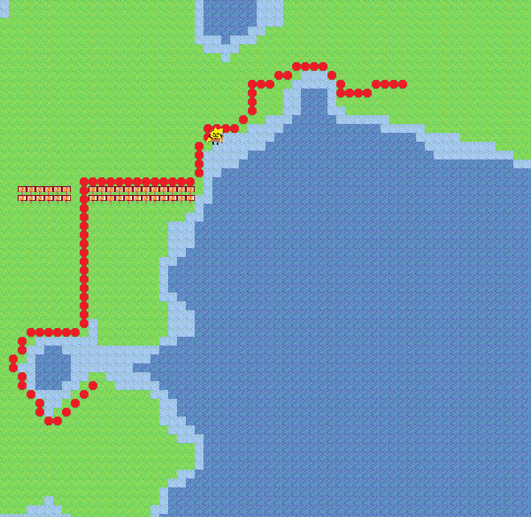Screenshot of the application
Summary
The purpose of this project is to analyse and answer some questions regarding artificial intelligence in a procedurally generated world. Both primary and secondary research has been carried out in an attempt to answer these questions and a prototype application has been developed with some implementations which is critically analysed later in this report.

The application is a model that generates a large landscape of terrain using Perlin noise and cosine interpolation and presents the world in a 2D top down view, the terrain has different heights each represented using different sprites for the grid tiles and each with a different cost of movement. An agent can move about the terrain and will appear to do so intelligently as it plots its course using an integration of the A* path finding algorithm.

Different techniques have been considered for each task including Perlin noise, midpoint-displacement and cellular automata for procedural generation, linear and cosine interpolation for plotting terrain height values between gradient vectors as well as A* and Dijkstra's algorithm for path finding. The techniques implemented into the final prototype is Perlin noise with cosine interpolation and A* for the path finding.

Perlin noise was chosen because of its advantage of being able to pass world coordinates to it as a seed and have it generate the same data if the same area of the world is revisited. Cosine interpolation was found to be superior to linear interpolation because it gave a smoother more organic appearance to the terrain when transitioning between gradient vectors and finally A* was chosen because of the speed at which it can evaluate the terrain nodes and find a solution quickly even if that means occasionally finding a sub-optimal route instead of the single most fastest route.

There is room for improvement with cosine interpolation however as it only gives a smooth transition around the gradient vectors themselves but is still relatively linear in the more central areas between gradient vectors and is always guaranteed to pass through all gradient vectors sometimes causing sudden drops and elevations. The path finding could be further developed by partially integrating another algorithm such as Dijkstra's so that it is more likely or even certain to find the most optimal route and avoid getting lured into a dead end as is sometimes the case with the A* implementation (more information can be found about this through Appendix IV), given the nature of the generated terrain however this is a rare occurrence which is one reason why A* was finally chosen over Dijkstra's algorithm for path finding in this model.

Biography
I chose this project initially because of my interest in procedurally generated data and artificial intelligence, C++ is my most experienced programming language and I felt that it would give me the tools I needed to tackle the research questions in this project in my own implementation. I hope to pursue a future in AI and use this project to answer some of my own questions about the limitations of AI in procedural worlds and use this new knowledge and experience to help me in my future career. One of my main interests in this project is creating a super massive world using procedural generation and trying to find a way of creating an AI which is capable of traversing and expanding its domain within the world learning as it progresses, to put it simply I often imagine an RTS game type AI in a huge procedurally generated world without limit or capacity on its size or speed of expansion and then imagine it growing exponentially.

How to access the project
The github repository for the project files can be found here: https://github.com/GrantCTP12016119/Dissertation.git

This will contain all C++ project files as well as a release build of the application with all textures in the same directory within the folder “textures” that the application is dependant on. Keeping the same file structure as seen in the repository is required. The application will also come with a README explaining how to use it.

The project uses DarkGDK which is needed to recompile the project in visual studio but will not be needed to run the release build supplied in the github repository. The normal C++ .cpp and .h files will also be available in the project folder titled “Procedural_World_2D”.

The video demonstrating the final implementation can be found here: https://www.youtube.com/watch?v=abKQx1Hw9bQ&feature=youtu.be

Introduction
This project is about Artificial Intelligence in procedural environments and how AI can be used to navigate a piece of terrain whilst appearing intelligent and adapting if that environment changes. AI path finding in games often require the developer to insert some sort of navigation mesh over the terrain to highlight areas where AI can move, this can take a lot more time compared to an algorithm that is capable of processing the world and automatically placing nodes at various places where it marks areas that AI are able to traverse. Furthermore with a procedural world which can come in much larger sizes than hand crafted worlds, having an algorithm to perform this task for the developer is really the only option as manual placement of these nodes and indicators would simply take too long.

While navigating the terrain, it must also be able to distinguish between areas that cannot be traversed and also be able to detect the difficultly of reaching certain areas assigning them a cost of movement, for example a mountain would cost more than a piece of grass, however an interesting exception to this is that if the agent is already elevated on a mountain then these values would surely change which introduces another question, is it possible to create an AI that is capable of knowing when staying on a mountain or contour is beneficial, instead of climbing down only to climb back up again given that its goal node is on an elevated piece of terrain.

This project also explores the generation of terrain with using different interpolation algorithms integrated into the Perlin noise to modify how the terrain looks with the goal of finding the best interpolation method for generating the most organic looking terrain.

Methodologies
To summarise upon the research report there were three main tasks of which each had a number of different methods associated with them. The tasks were Procedural generation, Interpolation and Path finding. The procedural generation techniques analysed were Cellular automata, Midpoint displacement and Perlin noise and it was found that these three methods are all iterative operations and octaves or passes are applied to create a more complex and non linear set of results for example different amplitudes and frequencies can be applied to different octaves when using Perlin noise to achieve more unpredictable results.

For interpolation both Linear and Cosine interpolation was researched, linear interpolation provides a dot to dot appearance on a 2D graph with a line moving linearly between vectors creating pointed peaks and drops whereas cosine interpolation creates a smooth curve between each vector while still passing through each vector creating rounded peaks and drops on the graph.

Finally the path finding methods looked at in the research report were A* and Dijkstra's algorithm, A* is a heuristic and Dijkstra's algorithm is not, this means that Dijkstra's algorithm searched the entire grid of nodes starting at the start position and end at the goal node, when the goal node is reached it traces its parent path back to the start node. A* works in a different way where it used an estimation of the distance from the goal node and uses this information to select which open node to evaluate next in some cases reaching the goal node quicker than Dijkstra's algorithm. Some additional information can be found under Appendix III.

Furthermore there is additional research that has undergone during this project that can be found in the appendix and is discussed in further detail later in this report.

There are many games which have AI moving throughout terrain particularly in RTS games but finding out their methods was not possible as many of these games are commercial and not open source, this meant that most of the research had to be done looking at math, theory and other professionals research papers as well as primary research of experimenting with the different techniques available for achieving certain tasks.

While developing the prototype, linear interpolation was used initially to assign the terrain values between the gradient vectors on the 2D grid for the terrain, although the method worked fine it was not the most organic look for terrain, it gave a pointed look to hills and shore lines instead of a smooth curve, this was because the linear interpolation as the name suggests was linearly transitioning the heights of the terrain between the gradient vectors without at any point smoothing out the effects. Further algorithms were looked at to address this issue finally coming across cosine interpolation which uses a cosine function to smooth out the areas around gradient vectors and give a much more organic and satisfying look to the terrain (Abel Gomes, 2010), along with the multiple octaves from the Perlin noise the generated terrain began to look more like a natural landscape.

Results
There are various outcomes that lend aid to answering the questions that were the purpose of this project and some improvements that could be made if this project is taken further.

With regards to path finding there were a number of accomplishments, one of which was the ability for the A* algorithm to find the solution quickly as the user clicks on the screen and on a high end gaming computer the calculation for a large path is instantaneous. The nature of A* no doubt helped with the speed as it is always moving towards the goal node and only branching outward if an obstacle is encountered.

Another success is the ability for the AI to stay on contour lines with the setting that can be toggled in the menu, this means that the agent will avoid descending in the event that its goal node is also on an elevated area, and will always avoid moving to a node that has a cost that differs from its current node when possible. This of-course also means that when the agent is in water it will attempt to remain in the water and similarly for grass and any other terrain type.

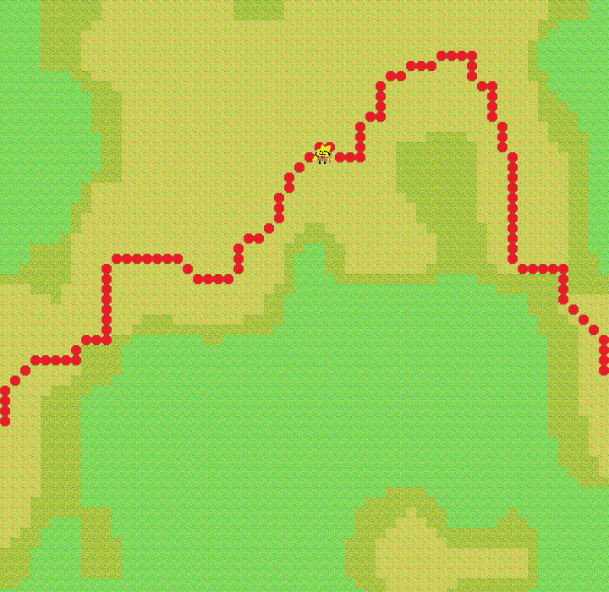Figure 1: The agent moves from its start node to the goal node staying on the mountain areas without needlessly descending only to have to ascend again
Additionally to staying on contour lines the algorithm is also capable of valuing different types of terrain with costs that can be changed to alter the way they navigate the terrain, the algorithm can be changed to remain on grass as its default setting, prefer mountainous areas, or even prefer to remain in the water.

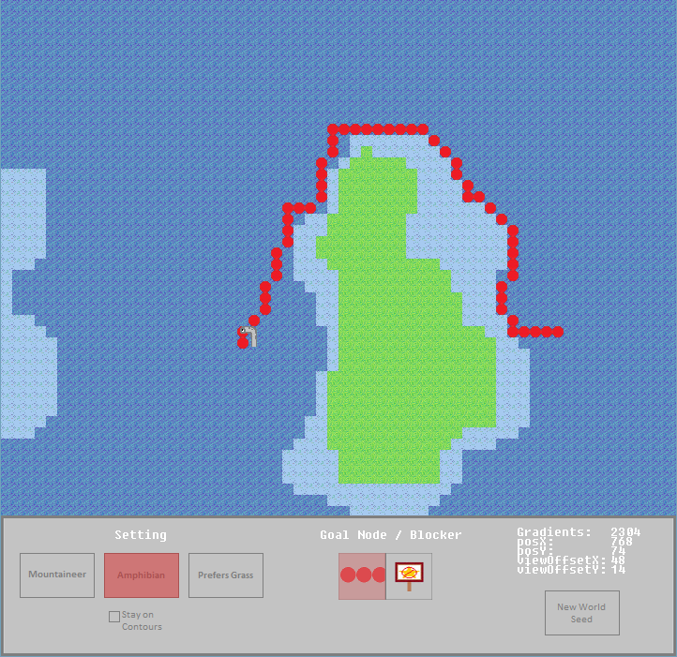Figure 2: In this example the amphibian setting is selected in the menu at the bottom of the screen and as a result the agent above is moving around the grass area staying in the water whilst moving toward its goal node
Another success was getting the algorithm to ignore nodes that blocks were placed on, these blocks can be selected in the menu and then placed on any tile in the view, the terrain will remain below them but the node will be disregarded in the A* path finding algorithm.

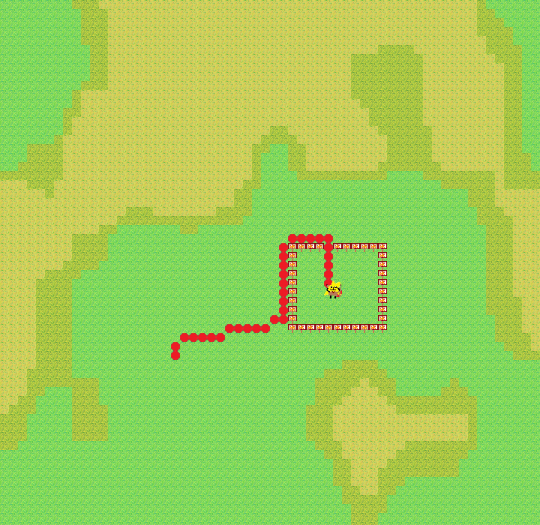Figure 3: Blocks are placed in a square shape with a small gap a single tile wide at the top and the agent finds and passes through the gap disregarding all nodes that have been marked with blocks
One disadvantage of using A* is the sacrifice of the guarantee that it does not always find the optimal route, this is because of the constant moving toward the goal node when there is no obstacles and only when it encounters an obstacle will it search outward for a way around it. This is because the distance of an open node to the goal node is taken into account when deciding which open nodes to evaluate next causing a sort of gravitation pull toward the goal node when other open nodes cannot be decided between using just their movement costs in the event that they are all the same type of terrain.

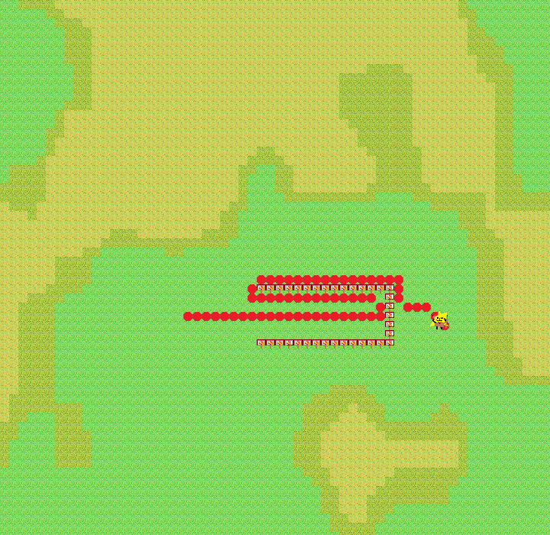Figure 4: An example of A* algorithm moving directly toward the goal node only to find its path blocked and having to re-route itself back out of the dead end and back around finally reaching the goal node
In the above example A* is clearly not effective at finding the optimal route but this scenario is a rare occurrence in the open terrain that has been created using the procedural generation methods in this model. Most of the time the A* algorithm finds its goal node quickly as it'll always be moving toward it whereas in another algorithm such as Dijkstra's for example the distance to a goal node is not taken into account and thus the algorithm doesn't move toward it ultimately taking longer compared to A* to solve simple routes as a result (see Appendix IV for more insight into A* and Dijkstra's algorithm). A possible solution could be to create a hybrid path finding algorithm between A* and Dijkstra's, perhaps still using the distance to the goal node to move toward to the goal node but also occasionally searching outward for multiple paths instead of following a single path blindly into a dead end.

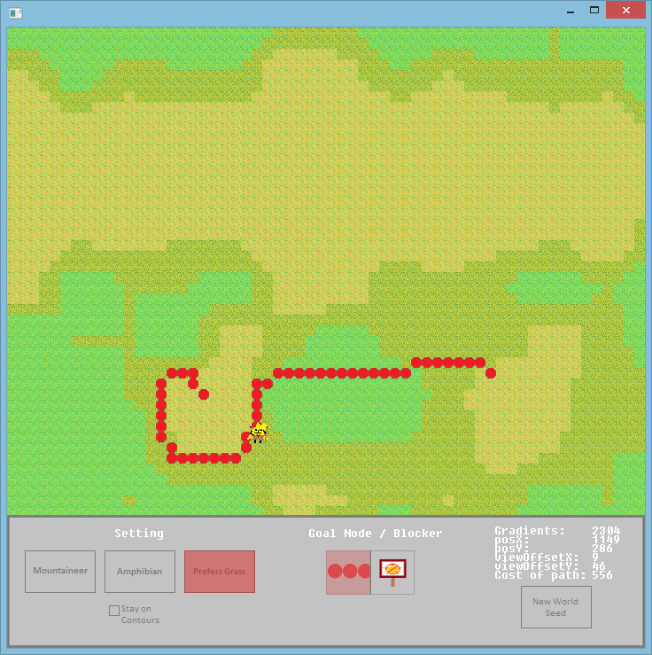
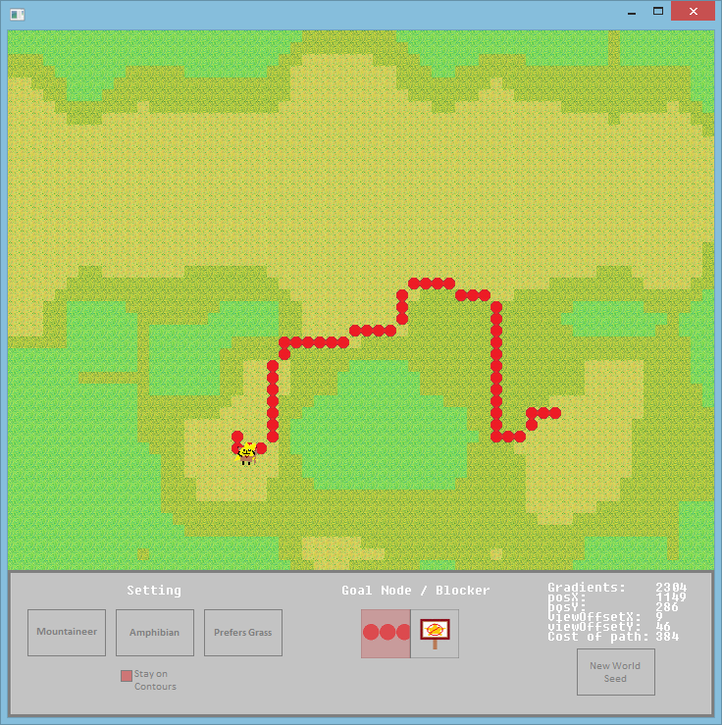
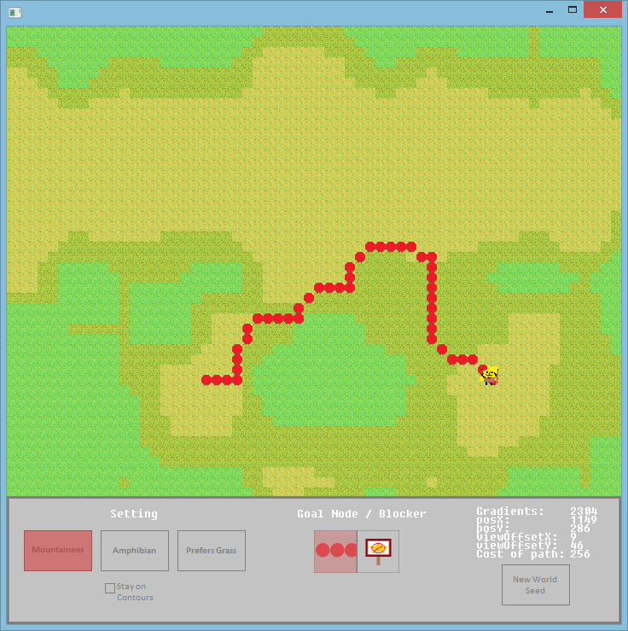
In the above images a mountain range is traversed using three different configurations each resulting in a different final path cost. The below table shows the data in each image starting from the left.

Configuration | Cost of path
Prefers Grass | 556
Staying on contours | 384
Mountaineer | 256

It is clear here that the prefers grass option has cost much more than the mountaineer or contour follower, this is because both the starting position and ending position are on mountain peaks with a grass land separating them meaning that when the agent that prefers grass descends to make contact with the grass area they inevitably have to re ascend costing much more than that of the other two configurations who prefer to stay on an elevated area.

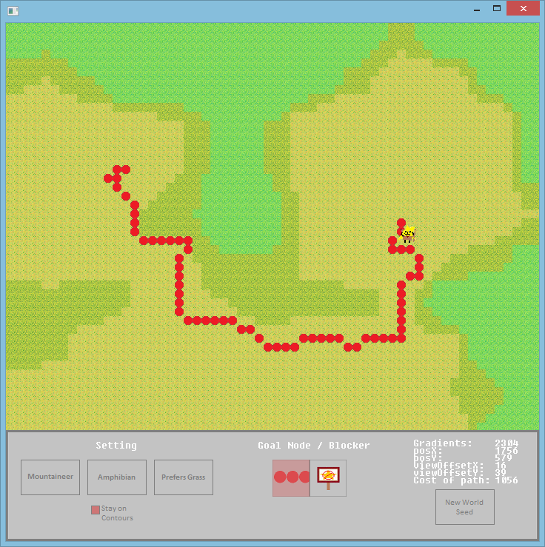Cost of path: 1056. Agent moves along the contour to reach goal
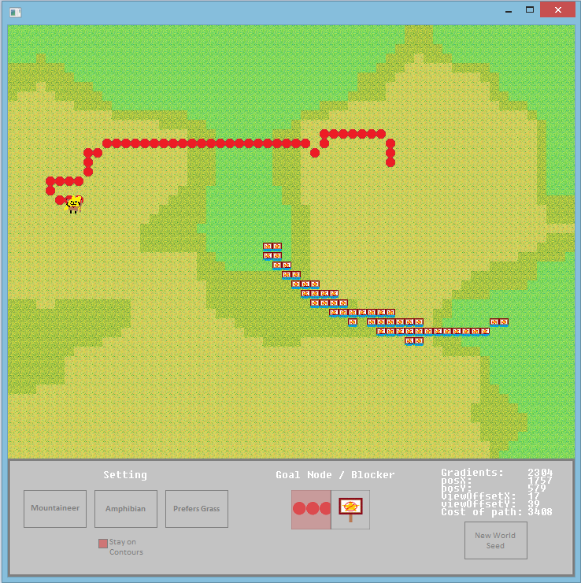Cost of path: 3408. Agent is forced to descend the mountain to reach the goal node as the preferred path has been blocked
Here is another example of the contour configuration, on the left is an agent moving around a mountain contour avoiding the grassland in the centre and thus achieving a lower costing path whereas on the right the mountain contour has been blocked causing the only viable option to be to cross the grassland which results in a larger cost as a penalty for descending only to reascend again.

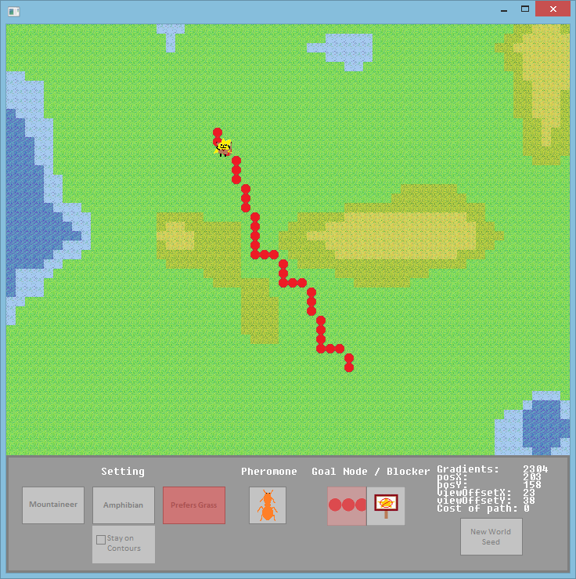Agent moving between the two mountain areas
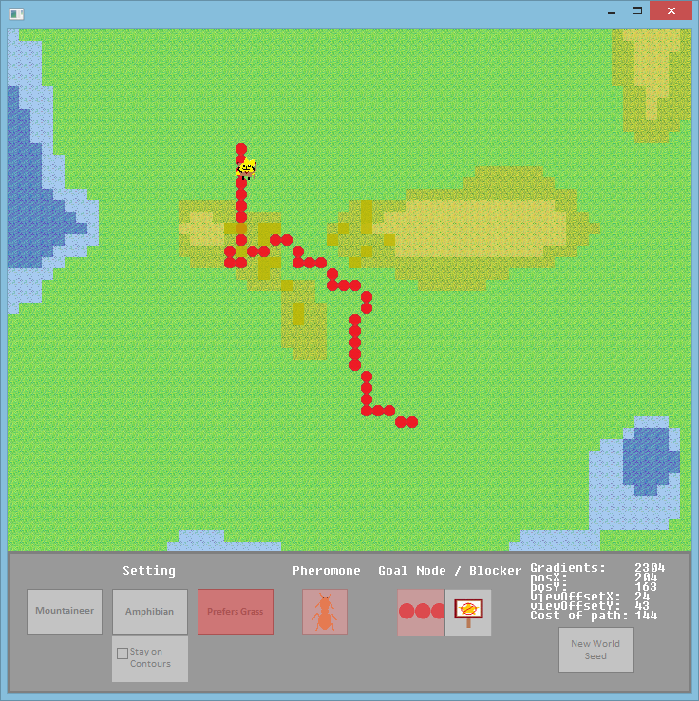Agent responding to the presence of pheromones on the hillside and climbing to pass between them
In the above image on the left you can see an agent moving through a gap between two small mountains and on the right you can see that some pheromones have been placed on the hillside causing the agent with the prefers grass setting enabled to actually climb the hill to pass amongst some of the pheromones before proceeding to the goal node.

As for the Perlin functions the initial problem discussed in the above section about linear interpolation was solved using cosine interpolation which gave a more organic transition between gradient vectors, this method however does have one flaw which could be improved upon in the future. Cosine interpolation provides a smooth transition but only as it crosses over gradient vectors meaning that the area between is still linear. True linear interpolation representing a single elevated gradient vector on some terrain would give the appearance of a diamond from a top down perspective. With cosine interpolation there is still a diamond shape but with rounded off corners this is because cosine interpolation is a modification of linear interpolation, whereas the most organic appearance would be just a regular circular shape representing a single elevated gradient vector.

angle = V * pi
C = (1 – cos(angle)) * 0.5
G = v1 * (1 – C) + v2 * C

In the above math example where V is the position between the two gradient vectors and v1 and v2 are the two gradient vectors being interpolated between with G representing the final result of the cosine interpolation.

Discussion
Some questions were tackled by this project such as, which procedural generation algorithm is best suited for generating data to represent an organic looking landscape and which path finding algorithm can perform faster and appear logical in the generated world. These questions were answered and solutions found with some pros and cons for each. Each of the algorithms explored in this project all have advantages and disadvantages associated with using them and this may help professionals move in their desired direction after looking at the results of this project and research paper. As well as answering questions this project has also given rise to some new questions such as how could agents be made to react to each other intelligently if multiple agents were placed in the procedural world? Would they share information? Use pheromones to help direct each other? How could some sort of decay or erosion algorithm be applied over procedural generation to give the affect of eroding shore lines, mountain passes or even generating procedural cave systems underneath the terrain?

Some further research has been completed preceding the research report which has introduced some additional methods and algorithms one of which being the D* path finding algorithm (please see Appendix I). The nature of the D* algorithm makes it a good choice for when a natural behaviour is desired, one in which the agent doesn't know a whole lot about the environment and/or if that environments is dynamic and capable of changing in real time.

Additionally another concept was researched to do with Pheromones (Appendix II) which can also be used for path finding and AI decision making, Pheromones could be used either by agents leaving a trail in their paths or objects in the world giving off a certain Pheromone to which different agents respond to in their own manner. This may be repelling or attracting or causing the agent to do some action.

This project could have a future impact on the industry with regards to analysing how AI can survive and/or adapt in an unknown environment as well as navigate it logically. Further development may be necessary for this and could involve the incorporation of neural networks and genetic algorithms for simulations. Some simulations could include predator vs prey situations or a civilisation adapting to its environment as it build and expands. This may be desirable for simulation games as developing advanced AI could enhance the single player experience and even eliminate the need for a multiplayer one.

Finally other professionals can draw from this piece of work one implementation of combing both procedural generation of terrain and AI path finding about it, there are many combinations with different outcomes and results suited for different goals, this project however focuses on providing answers to solving the complexities of applying AI in a procedural world for the use of realistic simulations and perhaps future real time strategy games.

Conclusion
To conclude, it was found that the A* path finding algorithm is a good candidate for navigating terrain because of its speed and because of the rarity of the dead end problem that was explained in the results section. For future projects a recommendation would be to consider using Dijkstra's algorithm if speed of computation is not a concern as the benefit will be smarter obstacle avoidance and D* if the desire is a more natural behaviour in an unknown or dynamic world with agents capable of re-ploting a portion of a path if an obstacle is encountered.

Furthermore cosine interpolation gives an organic look to the terrain when interpolating between gradient vectors and is a modification of linear interpolation. For the future a more advanced interpolating algorithm may be looked at for increased realism and an even more organic look, this may require an interpolating algorithm that is capable of interpolating between more than two vectors at once.

This project could be taken further in the future to introduce multiple agents and add crowd behavioural algorithms to simulate behaviour as well as path finding, agents basing their chosen paths taking into account the current positions of other agents and their respective paths, potential predators or friendly agents that want to stay together and perhaps path finding algorithms that have agents move in group formations.

References
Dave Ferguson and Anthony Stentz, N/A, The Field D* Algorithm for Improved Path Planning and Replanning in Uniform and Non-Uniform Cost Environments, Cernegie Mellon University, https://pdfs.semanticscholar.org/58f3/bc8c12ee8df30b3e9564fdd071e729408653.pdf.

John Sauter et al, N/A, Tuning Synthetic Pheromones With Evolutionary Computing, http://citeseerx.ist.psu.edu/viewdoc/download?doi=10.1.1.12.1829&rep=rep1&type=pdf

Randy Nelson, 2010, Will Wright explains what The Sims and an ant colony have in common, Engadget, http://www.engadget.com/2010/11/08/will-wright-explains-what-the-sims-and-an-ant-colony-have-in-com/

UNSWMechatronics, 2013, Dijkstra's Algorithm vs. A* Search vs. Concurrent Dijkstra's Algorithm, https://www.youtube.com/watch?v=cSxnOm5aceA

Abel Gomes, 2010, Interpolating Methods, (N/D), http://www.di.ubi.pt/~agomes/tcg/lectures/04-lecture.pdf.

Appendixes

Appendix I
D* algorithm is another path finding solution which is an extension to the A* path finding algorithm, mainly used for unknown or dynamic environments, in the face of an obstacle D* repairs its path to move around it, this gives a more natural look to an agent trying to reach a goal node instead of for example automatically seeming to know all of the dead ends and passage ways of a maze and move straight to the goal node. Upon calibrating a route D* keeps all of the information about the surroundings whereas A* throws the information away and simply only cares about the nodes that make up its chosen path. (Dave Ferguson and Anthony Stentz, N/A)

Appendix II
Pheromones can be simulated in computing in a way that reflects how some insects find there way around the environment, this is an interesting concept to consider when looking at how an agent could navigate around a 2D terrain using pheromones to decide on which grid spaces to move through. Pheromones can be programmed to give off a different flavour and thus cause the agent to treat the object emitting the pheromone differently (John Sauter et al, N/A)

One example of the use of Pheromones in AI behaviour is the video game 'The Sims' developed by Will Wright. In The Sims each agent or Sim (as they are named in the game) respond to pheromones that are given off by different objects in their environment each with a different intensity and each with one of eight different flavours representing the eight motives in the game.

A quote from Will Wright in an interview article “"The basic engine for The Sims really ends up being one of any pheromones. Every object in the environment is sending out an 'advertisement' of pheromones in a particular flavor. The flavors are the eight basic needs of the Sims. So they can advertise 'food,' 'energy,' 'fun,' 'social,' 'hygiene.' Every object is described in those terms, being the collection of pheromones that it broadcasts," Wright explained. “ (Randy Nelson, 2010)

Appendix III
Through the secondary research came the conclusion that A* was faster than Dijkstra's algorithm but that comes at the penalty that A* is not always guaranteed to find the fastest route to the goal as it tends to skirt around obstacles rather than completely avoid them. (UNSWMechatronics, 2013)

Appendix IV
Grant Medlyn, Research report, can be found in the git hub repository included with this project.

Appendix V
PCG family for better random numbers, random number generator library used in this project and the code of which can be found in the pcg.h file in the project, http://www.pcg-random.org/

